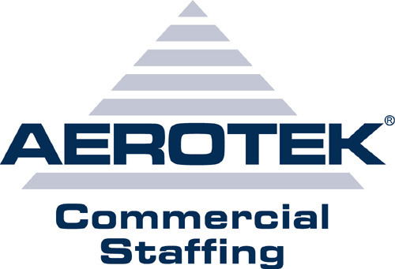

Myla Mengote Velasco
Objective:
To obtain a challenging production operator position in an
organization that offers professional growth and good benefits.
Offering 15+ years of Manufacturing Expertise.
Work History:
05/2007 – 07/2008 St. Jude Medical/ ANS Plano, TX
Production Assembler
Performed various production operations that assembles medical device using RF machine and Laser machine. Worked in molding room, laser room performed a multiple operation in the production line.
2000 – 2006 Boston Scientific Murrieta, CA
Product Builder III
As a Product Builder I performed various lead operations (Worked as Assistant Lead). Assembles PTCA Catheters. Signing and follow Line Clearance Procedure and Batch Traveler. Knowledge of mixing Epoxy, Urethane, silicone, tonox, MDX, and any other chemicals that are being used in the production. Work in QC department for inspecting printed labels for packaging. Work as a lead in some departments in and out of the Clean Room (Packaging, MDX-ing, Blade Casting, Blade Inspection and Blade Trimming). Knowledge of identifying rejects or bad products, labels and very consistent of any count, numbers and letters. Experience on hand held tools and hand operating machines.
09/1999 – 04/2000 Humphreys San Diego, CA
Production Assembler
Performed various Production Assembly by assembling Gyroscope. Assemble and disassemble product by using power tools. Doing some Wiring, Harnessing, and Soldering.
1992 – 1999 Medtronic San Diego, CA
Production Assembler Operator
Performed various operations that assembles PTCA catheters. Installing designated components by using hand held tools. Operates machines that bonds materials or components. Operated Instron machines that deals with pull testing in bonded parts. Knowledge of maintaining proper documentations. Entering data into the Material Tracking Control System (MTCS).
Skills and Training:
Gowning Procedure CMA/Clean Room
Workmanship Standards
Microscope Training
Safety Training
Handling/ Disposal of Hazardous Waste
Familiar with GMP, MSDS, and ISO9000
Certified Machine Operator
Bonding Machine, Blowing Machine, EDM Machine, Blade Casting Machine,
Trimming Machine, Stamping Machine, Sealing, UV, MDX, Conveyor.
Education:
St. James High School - High School Diploma (1986) - Philippines

